­

October 2023

Newsletter

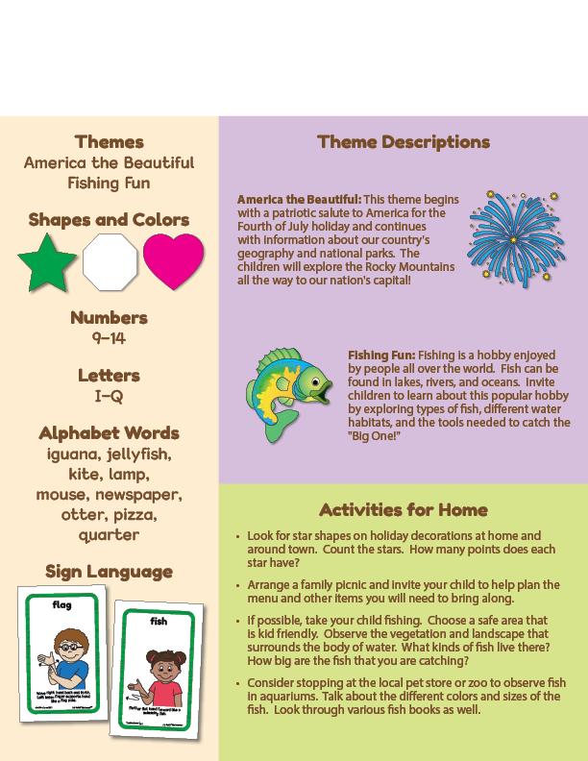Newsletter

**Add Your Name/Logo Here**

**Add Text**